**PRACTICAL TASK 1**

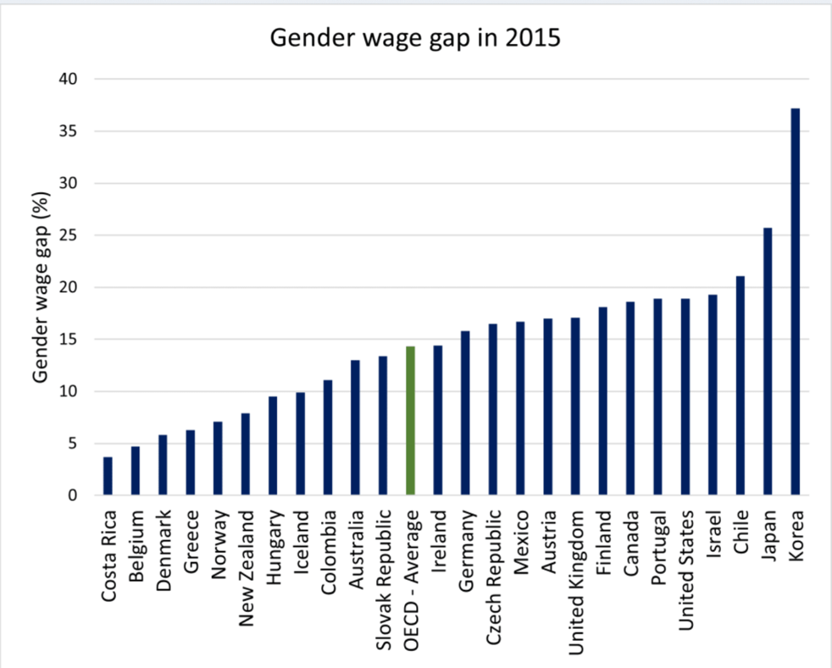

* Costa Rica, Belgium & Denmark
* Korea, Japan & Chile
* Costa Rica had made major investments in education, resulting in higher levels of female participation in the workforce. When women have access to quality education and training, they are more likely to enter higher-paying professions, reducing the wage gap. Costa Rica also has a comparatively high level of female engagement in the labour force compared to neighbouring countries. As women become more involved in the workforce, it can contribute to narrowing the wage gap by intensifying competition for skilled labour and mitigating gender-related biases and discrimination.

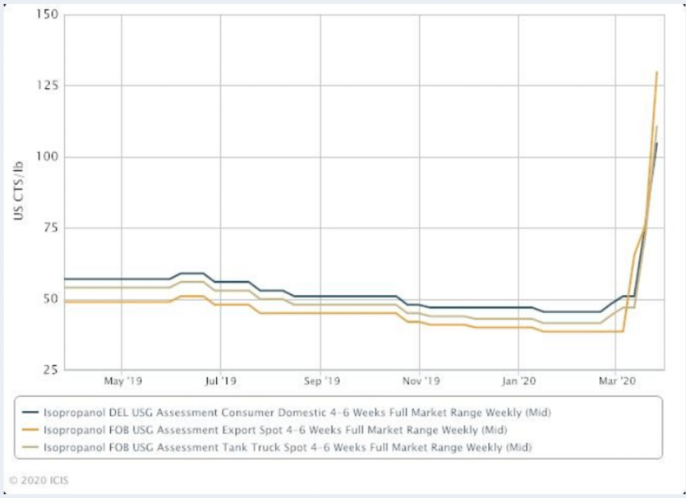

* From March 2020 the graph shows that as the sales of isopropanol shot up significantly which resulted in March 2020 being the highest month of sales out of the other months shown. More lbs of isopropanol were also sold during that month the highest being under 125lbs.
* Covid-19 was declared as a pandemic on 11th March 2020 by the PHEIC, which resulted in what was once seen as the usual hand sanitiser became one of the world’s top most wanted items for households and as isopropanol is used in

many hand sanitisers.

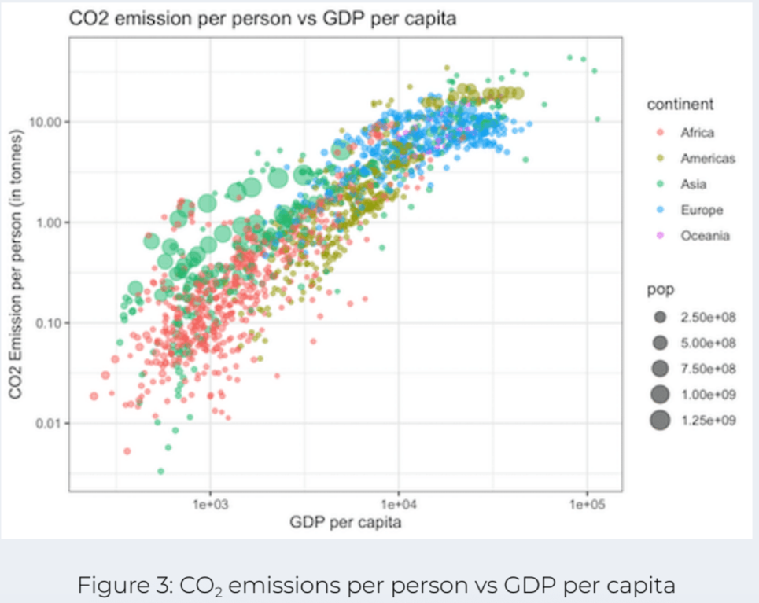

* In Africa the larger population shows more scattered, it shows that CO2 emission per person is low between 0.01- 0.10 tonnes and that the GDP Per capita is also low which is less than 1e+03. But where the population is smaller it shows more clustered as the CO2 emission per person going higher especially between 0.10-1.00 tonne from 1e+03.

In the Americas the CO2 emission per person for the low population is scattered between 0.10-1.00 tonne but as soon as it gets over 1.00 tonne the population shows more clustered especially between 5e+03 and 1e+04. However, the high population which is clustered is also high in CO2 emission per person about 10.00 tonnes.

In Asia where the population is low shows more scattered and ranges from under 0.01 tonnes to over 10.00 tonnes CO2 emission per person. It does become a bit more clustered between 0.10 – 1.00 tonne CO2 emission per person and continues to go up when the population is high at 1.00e+09.

Europe only shows a small population which is clustered when CO2 emission per person is between 1.00 – 10.00 tonnes. There are a few scattered where the CO2 emission per person is between 1.00-5.00 tonnes between 1e+03 and 1e+04 GDP Per capita.

Oceania is shows scattered from 1e+04 GDP Per capita and where the CO2 emission per person is between 5.00 and just over 10.00 tonnes but the majority being under 10.00 tonnes.

**PRACTICAL TASK 2**

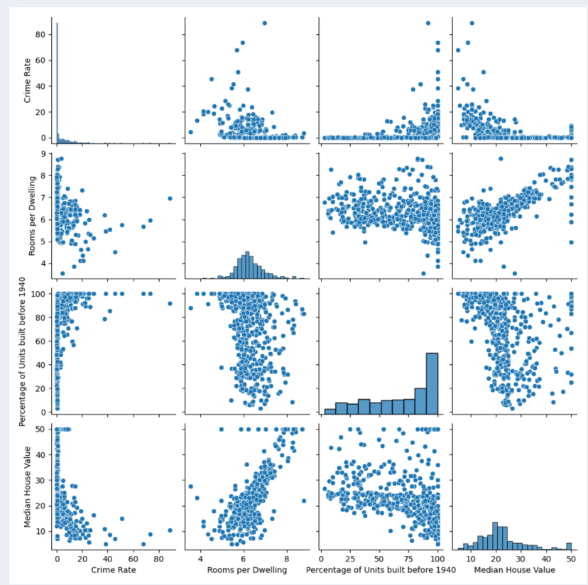

* Similar to the correlation between Rooms per Dwelling and Median House Value, a correlation coefficient can be calculated to determine the relationship between the Percentage of Units built before 1940 and Median House Value.
* The graph that best represents the population of Boston population is the scatterplot showing the percentage of units built before 1940. Boston has a low crime rate because when house values go up, crime rates tend to go down.
* The average number of rooms per dwelling in Boston is 6.
* The correlation between Rooms per Dwelling and Median House Value is that as the rooms per dwelling goes up so does the median house value.
* The majority of the units build before 1940 are relatively old.
* The correlation between the percentage of units build before 1940 and the median house value is that the units built before 1940 have a lower median house value and continues to go down the older the unit is.